**30 Days of Machine Learning |Syllabus**

Educator Name: Nishant Dhote

Contact: +91-7880-113-112

**Part: 1**

**Day: 1 Introduction & Type of ML**

**Link:** [**https://www.youtube.com/live/8uDZjeXVa_4?si=v7rgw8HAWABjEPFa**](https://www.youtube.com/live/8uDZjeXVa_4?si=v7rgw8HAWABjEPFa)

* What is Machine Learning
* How has Machine Learning evolved? The History of ML
* ML vs DL vs AI
* Data Science Vs Data Analytics Vs ML/AI/DL
* Types of machine learning

**Day:2 Batch | Model | Instance Based ML**

**Link:** [**https://youtu.be/cgmgR7ELjcQ?list=PLxzTa0VPR9rzus4Egb-aOmCWier5XiOba**](https://youtu.be/cgmgR7ELjcQ?list=PLxzTa0VPR9rzus4Egb-aOmCWier5XiOba)

* What is Batch / Offline Machine Learning?
* What is Online Machine Learning?
* Difference Between Online Vs Offline Machine Learning?
* Instance Based Machine Learning.
* Model Based Machine Learning.
* Instance Based Vs Model Based Machine Learning.
* Challenges in Machine Learning.
* Application of Machine Learning.
* Machine Learning Development Life Cycle.

**Day:3 MLDLC | CSV / JSON / SQL Data Gathering**

**Link:** [**https://www.youtube.com/live/zT-gIdeF5Ks?si=Ctpz6673FHpwqnr5**](https://www.youtube.com/live/zT-gIdeF5Ks?si=Ctpz6673FHpwqnr5)

* Machine Learning Development Life Cycle (MLDLC/MLDC):
* Data science life cycle (DSLC):
* Tools used in Machine Learning? Installing: Anaconda | Jupiter Notebook (IDEs)
* Optional Tools: Spyder | PyCharm | Noteable | Google Colab | Kaggle Notebooks | Microsoft Azure Notebooks | Apache Zeplin | Count.co and Many More
* How to import dataset and download data files?
* How we create virtual environment
* Data Gathering
* Working with CSV Files
* Working with JSON/SQL

**Day:4 Framing ML Problem | Fetching Data from an API**

**Link:** [**https://youtu.be/Kev-JHvEd40?list=PLxzTa0VPR9rzus4Egb-aOmCWier5XiOba**](https://youtu.be/Kev-JHvEd40?list=PLxzTa0VPR9rzus4Egb-aOmCWier5XiOba)

* Framing a Machine Learning Problem
* Data Gathering
  + Fetching data from an API
  + Fetching data using web scraping

**Day: 5 Web Scraping for Data Gathering**

**Link:** [**https://youtu.be/DaGrAC0jTOk?list=PLxzTa0VPR9rzus4Egb-aOmCWier5XiOba**](https://youtu.be/DaGrAC0jTOk?list=PLxzTa0VPR9rzus4Egb-aOmCWier5XiOba)

* Fetching data using web scraping

**Part: 2**

**Day: 6 EDA: Type of EDA | Univariate EDA**

**Link:** [**https://youtu.be/E0B6IrzBxHM?list=PLxzTa0VPR9rzus4Egb-aOmCWier5XiOba**](https://youtu.be/E0B6IrzBxHM?list=PLxzTa0VPR9rzus4Egb-aOmCWier5XiOba)

* Types of Exploratory Data Analysis:
* Univariate Analysis
* Bivariate Analysis
* Multivariate Analysis
* How We Understand the Data?

**Day: 7 EDA: Bivariate | Multivariate**

**Link:** [**https://youtu.be/pqqt3BXdVFo?list=PLxzTa0VPR9rzus4Egb-aOmCWier5XiOba**](https://youtu.be/pqqt3BXdVFo?list=PLxzTa0VPR9rzus4Egb-aOmCWier5XiOba)

* EDA Bivariate Analysis
* EDA Multivariate Analysis

**Day: 8 Panda Profiling | Type of Feature Engineering**

**Link:** [**https://www.youtube.com/live/JArbcZpvWuQ?si=lPVb9hhcD19RDuQ9**](https://www.youtube.com/live/JArbcZpvWuQ?si=lPVb9hhcD19RDuQ9)

* How do we use the pandas profiling tool?
* Feature Engineering
* Feature Transformation
* Feature Construction
* Feature Selection
* Feature Selection

**Day: 9 Categorical Variables | One Hot Encoding | Ordinal & Label Encoading**

**Link :** [**https://youtu.be/aG6rEJvQkEc?list=PLxzTa0VPR9rzus4Egb-aOmCWier5XiOba**](https://youtu.be/aG6rEJvQkEc?list=PLxzTa0VPR9rzus4Egb-aOmCWier5XiOba)

* **How to Encode “Categorical Variables”?**
* What is categorical data?
* **Type of categorical data?**
* What is Ordinal Data?
* Ordinal Encoding
* Label Encoding
* What is Nominal Data?
* One Hot Encoding

**Day: 10 Handling Missing Data | Missing completely at random (MCAR) | Complete Case Analysis (CCA)**

* Handling Missing Data
* What are the problems with missing data?
* Remove Missing Values
* What is a missing completely at random (MCAR)?
* Pro and Corns Complete Case Analysis (CCA)?
* When we use CCA?

 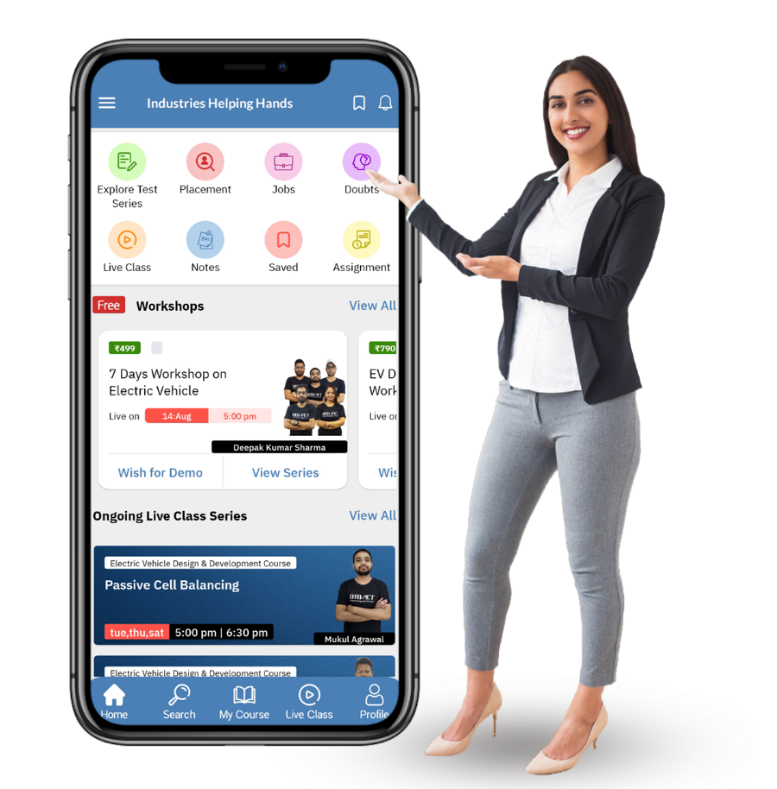

**Scan and download the App Now**

